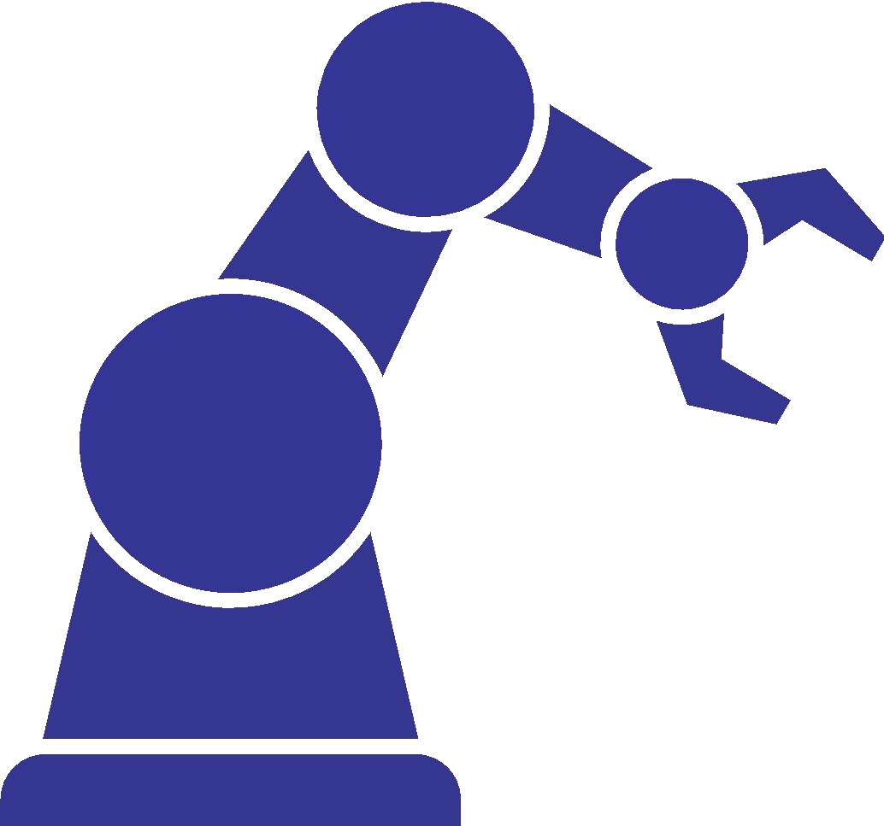
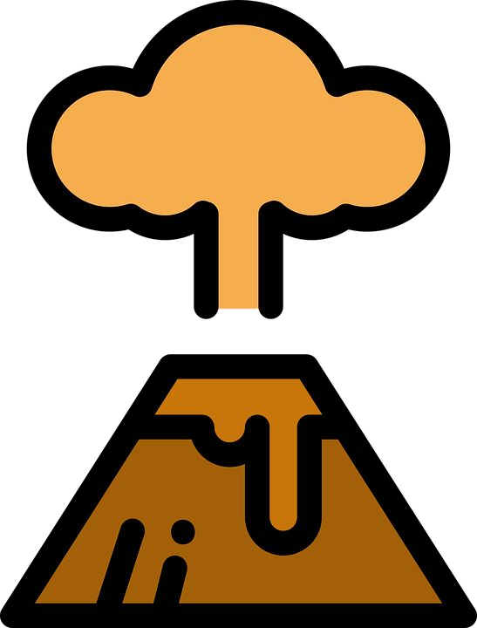
Science Instruction
Back-to-School Considerations
Science learning should be student-centered and consistently engage students in the practices of science and engineering. Instruction should facilitate collaborative sensemaking — a critical component of understanding phenomena and solving problems —
How can teachers continue high quality science instruction through different modes of teaching and learning?
in ways that honor student interest and identity.
Tensions We Are Navigating
- Students learn best when they engage in the practices of science and engineering; however, it may seem “easier” to use lectures, readings, quizzes, and memorization, which do not provide students sufficient opportunity to make sense of phenomena and solve problems.

- Teachers have implemented instructional strategies to provide high-quality, three- dimensional learning; however, converting to remote learning requires different tools and approaches. Teachers of science want to learn how to use tools for adapting science instruction, not just for general use (see vignette on following page).

- This is a moment of opportunity to redesign or replace learning activities that are not standards-aligned in order to create time and space for meaningful student engagement; however teachers need time and professional learning to adapt instruction.

- Schools may be familiar with inclusive practices for instruction, such as universal design for learning; however, adapting options for engagement, representation, and action in digital settings may present barriers to accessibility.
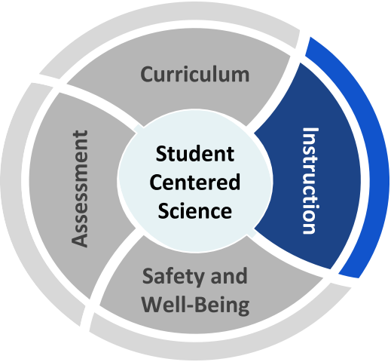

Recommended Reflection Questions
Use these questions with your PLC to examine current practice and engage in forward planning.

- What powerful instructional practices center students as sensemakers and co-constructors of knowledge and skills? How can these practices be adapted for different learning environments?
- What instructional practices might be reconsidered as ineffective or not aligned to a three-dimensional vision of science teaching and learning, e.g. busy work, rote memorization, vocabulary pre-teaching?
- How will you promote student engagement when modes of delivery are different than students may be used to or may change over time (e.g. rotating schedules, sudden return to online learning)?
- Which students are and are not being served in different modes of delivery? Whose interests are being centered?

Science Instruction
Where can we start?
Administrators
Understand the unique needs of science teaching and learning, and ensure that science is included in discussions and decision-making.
★ NGSS Overview for Principals
★ Science Practices Supervision Tools
★ K—8 Science During COVID (WestEd)
★ SREB Online, Blended, and Hybrid Instruction

Teachers
Adhere to a three-dimensional vision of science teaching and learning through purposeful selection of teaching strategies and technology tools.
★ OpenSciEd Remote Teaching
★ Role of E-Learning in Science Education
★ Designing Productive Uncertainty into Investigations
★ Adapting Science for Distance Learning
Students, Families, and Communities
Connect to high-leverage science teaching and learning practices, such as phenomena, science notebooks, and science talk.
★ Phenomena
★ Science Talk Moves
★ Science Notebooks

Back-to-School Considerations

Vignette: Tools and Approaches for Instruction
Use the Reflection Questions or Big Questions to guide a discussion with peers about this vignette.
Mr. Lee teaches high school biology and chemistry to mixed-grade classes. In face-to-face instruction, Mr. Lee’s students consistently engage in conducting investigations to gather data, reasoning through small group discussions using talk protocols and whiteboard modeling, and communicating in pairs, quads, and full class discussion, as well as individual writing.
In Mr. Lee’s district, blended learning will have students on different tracks alternating face-to-face and remote learning. Mr. Lee and his department use the SAMR model to select technologies to facilitate discussion and sensemaking for students with varying access to technology.
Mr. Lee plans to use technology on face-to-face days for several purposes. Some labs that cannot be safely modified will be replaced by simulations or micro- scale demonstrations that can be projected. Mr. Lee also plans to use document editing and video to allow students on opposite tracks to work together.
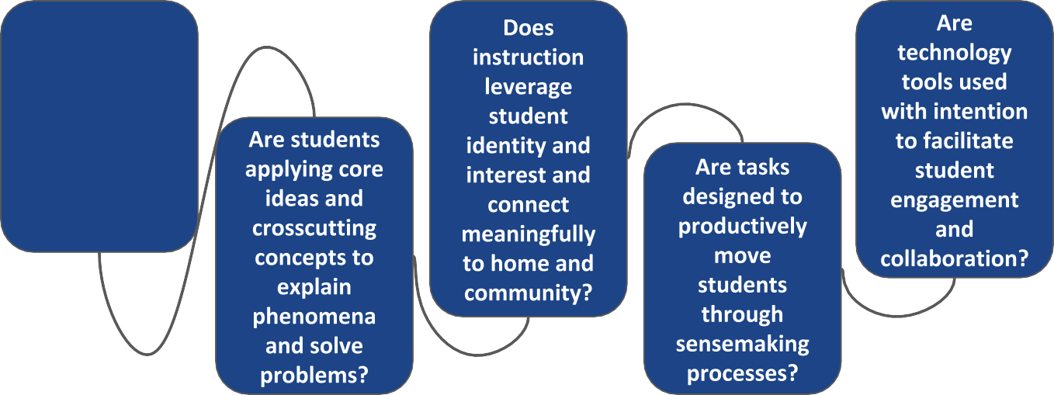
Big Questions for Instruction

Are students engaging in scientific and engineering practices?

