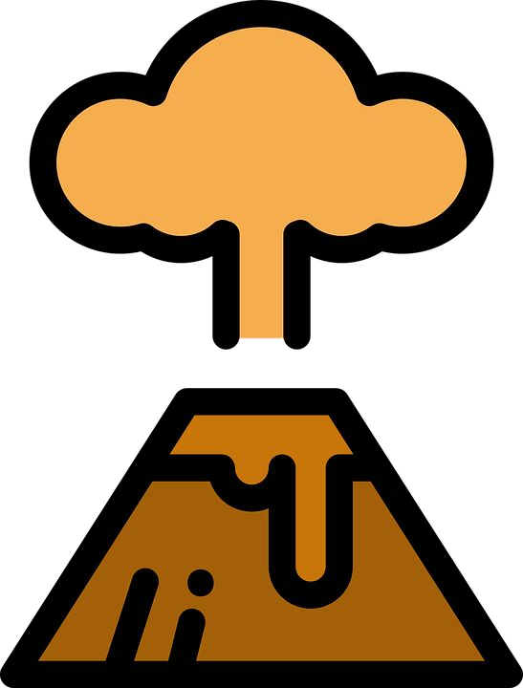
Safety and Well-Being In Science Back-to-School Considerations
What are the unique needs for student safety and well-being in science teaching and learning?
School closures, hybrid instruction, and school reopening have impacted teaching and learning across all content areas. Science has unique safety needs associated with face-to-face instruction related to investigation and discourse. Social-emotional
well-being also must be addressed.
Tensions We Are Navigating
- Communities have been impacted to varying degrees; and educators must recognize the disproportionate impact of COVID-19 on Pacific Islander, Black, American Indian/Alaska Native, and Latino/a/x communities; students with disabilities; and those in poverty.

- Safety is always a high priority in science, including the appropriate use of safety equipment; however, activities may need to be modified to adhere including physical distancing, additional personal protective equipment, and cleaning protocols.

- Collaboration and discourse are at the heart of student-centered science learning; however, face-to-face interactions need to accommodate health guidelines established by the district; online interactions may need additional supports to establish safe spaces for discussion.
- Social-emotional connections are critical to fostering sensemaking; however, creating and supporting relationships requires different structures in online environments.
- Student safety and well-being is a priority; and adults, including staff and families, must be also be supported.
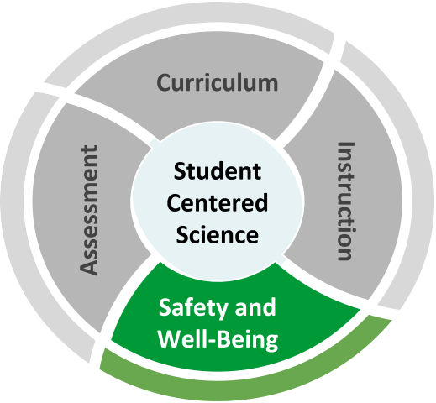

Recommended Reflection Questions
Use these questions with your PLC to examine current practice and engage in forward planning.
- Are there science topics that may need to be addressed differently or with additional care in light of the effects of the coronavirus in your community? How will you respectfully address the range of student experiences?
- What are the unique needs for science planning, instruction, classroom space, equipment/supplies, etc. with regard to student safety and well-being?
- What are the opportunities to leverage technology in powerful ways and to make connections to student health and social-emotional learning?
- Are resources for safe and supportive science teaching and learning accessible to all students? Are expectations clear for all teachers and families?

Safety and Well-Being In Science
Where can we start?
Administrators
Ensure that all aspects of safety are attended to for teachers and students. Understand the physical safety needs of face-to-face instruction and the complexities of interweaving SEL supports into science.
★ CDC School Guidance
★ SEL to Support Students and Families
★ The New Routines for Students When Schools Reopen
★ National Academies: Reducing
Transmission When Schools Are Open
★ Duty of Care in Science
Teachers
Maintain fidelity to district practices around safety and well-being in science.
★ safety Considerations for Science Investigation and Engineering Design
★ NSTA Safety Portal
★ CASEL CARES SEL Resources
Students, Families, and Communities
Stay up to date on the latest communications from your school district. Keep asking questions!
★ Practicing Safe Science at Home
★ Supporting Families During COVID-19
Back-to-School Considerations

Safety and Well-Being Vignette
Use the Reflection Questions or Big Questions to guide a discussion with peers about this vignette.

Dr. Reppuhn is a district STEM specialist who runs district Science/STEM PLN meetings. Teachers have asked her how to include coronavirus in science lessons. Some teachers are excited to use a timely phenomenon, but some are concerned that many students’ families have been impacted by the pandemic.

This year, Dr. Reppuhn reached out to her colleagues in School Counseling and Health Education for advice and input. They developed a list of considerations for addressing the pandemic in scientifically accurate ways that attend to students’ mental and emotional
well-being. They will share the list in a PLN meeting, and offer support to schools upon request.

Dr. Reppuhn also created a resource page for her district science website. She includes links to state, district, and federal guidance for health and safety for face-to-face and online modes of learning.
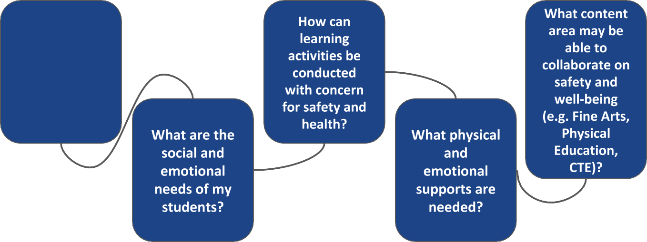
Big Questions for Safety and Well-Being

What are the science learning goals that need to be met?

