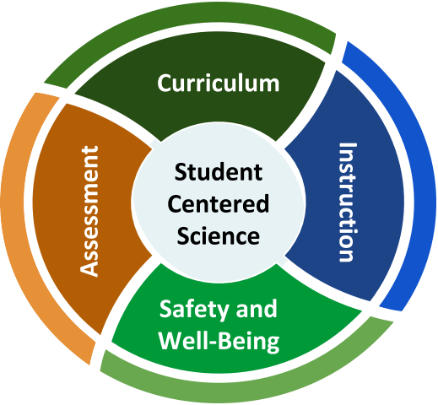
Science

Back-to-School Considerations
Effective instruction in science has students engaged in making sense of the world around them, asking questions, exploring and investigating ideas, and collaboratively creating authentic products that demonstrate standards-based learning. How can that happen as teaching and learning may be restructured?
Tensions We Are Navigating
- There is a need for clear and concrete guidance to move forward with teaching and learning in face-to-face, online, and hybrid modes; however, there is also a call to honor situations that vary across geography and are changing rapidly over time.

- Students, educators, and communities experienced a wide range of learning and life experiences during Quarter 4 of the 2019—2020 school year that impacted them in different ways; however, some are approaching a return to school with a deficit-oriented mindset and an overemphasis on recovery from “loss of learning.”

- Different materials and approaches may be needed to ensure high-quality, equitable science teaching and learning in different modes; however, districts are addressing realities around time, funds, staffing, online access, and physical spaces that may make teacher collaboration, materials adaptation, and purchasing a challenge.

- COVID-19 is a pressing concern for many educators; and, teachers of science also have to address social justice issues that affect the well-being of their communities and confront the ways in which science and engineering have historically exacerbated inequities.
What does effective science teaching and learning look like for possible 2020-2021 back-to-school plans?

Overview
This series of one-pagers addresses four areas for teachers of science, school/district science specialists, and administrators. These resources are designed to empower planning and support decision-making in ways that center students in science teaching and learning.
Curriculum — How should schools decide what needs to be taught in science while adapting to different modes of learning?
Assessment — How will we know what students know and can do when going back-to-school with different models?

Instruction — How can teachers continue high-quality science instruction through different modes of teaching and learning?
Safety and Well-Being — What are the unique needs for student safety and well-being in science teaching and learning?

Science 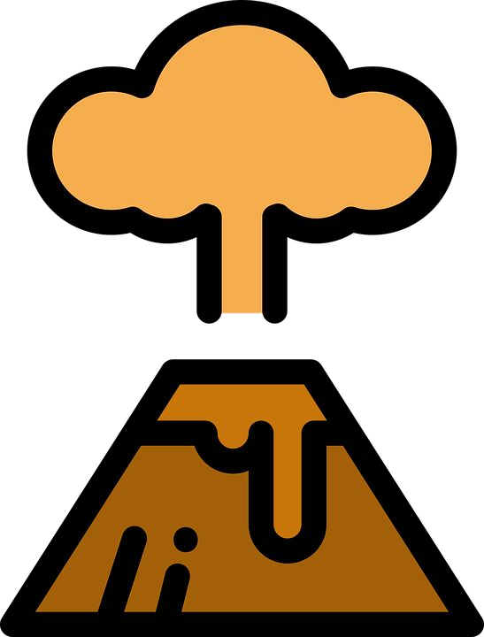 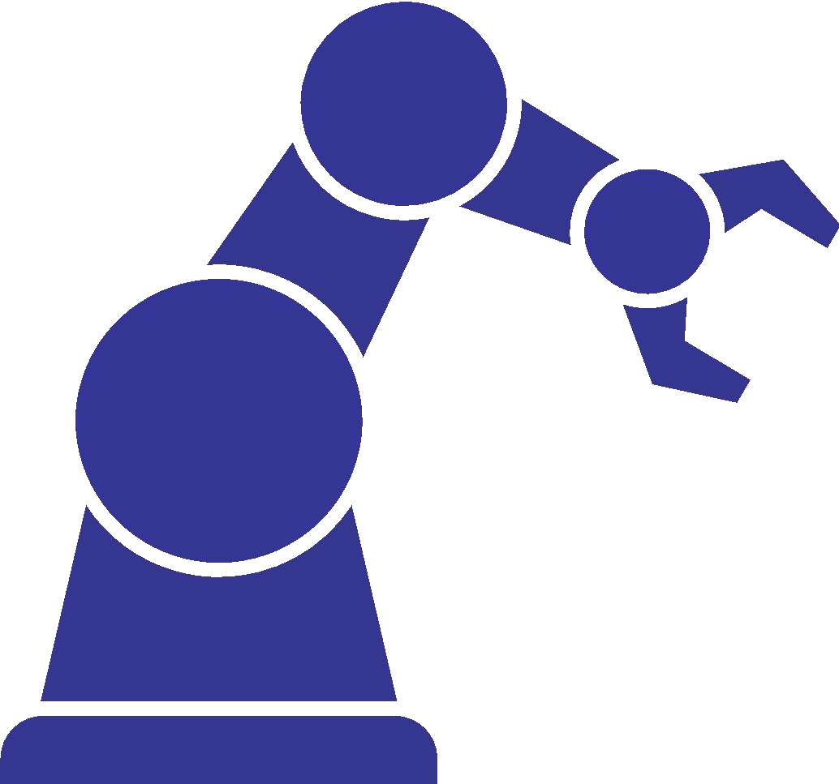
Back-to-School Considerations

Recommended Reflection Questions
Use these questions with your PLC to examine current practice and engage in forward planning.
- What will we need to know about our students? How can we tap into or rekindle students’ dreams and aspirations?
- What opportunities are open to make positive transformations and elevate promising practices? What inequitable or ineffective practices can be transformed or discarded?
- How will you support communities that have been disproportionately impacted by the pandemic?
- What routines and structures do you have in place for science curriculum, instruction, assessment, and social-emotional learning that can be adapted for the current context?
- How can you and your school team build policies and protocols that are responsive when new challenges arise?
Where can we start?
Policy Corner
Keep your eye on the following for policy updates:
- United States Department of Education
- Your state, district, school, and board of education
- Council of Chief State School Officers
- Education Commission of the States
- Johns Hopkins University eSchooI+ Initiative
- Lawrence Hall of Science
- Learning Forward
- National Academies of Sciences, Engineering, and Medicine Reopening K—12 Schools
- National Association of State Boards of Education
- National Governors Association Education
- School Superintendents Association
- Southern Regional Education Board
- Council of State Science Supervisors
- National Science Education Leadership Association
- National Science Teaching Association

Administrators
The Framework for K—12 Science Education establishes a vision of science for all students, with a goal of developing a scientifically literate society and preparing students with the skills, habits and understanding to be college, community, and career ready.
★ Speaking Up for Science and
Social Studies
★ Elementary Science: Equipping Students Through Inquiry and Integration
★ NGSS Appendix: College and
Career Readiness

Teachers
Equity goes beyond access and representation. It means honoring the cultures of our students, accommodating the histories of past and present traumas, providing the necessary resources and rigor, and helping students be a determining factor in forwarding their own learning goals.
★ Toward More Equitable Learning in Science
★ Equity STEM Teaching Tools
★ Kids Speak Out on Student Engagement
★ NGS Navigators

Students, Families, and Communities Families are more engaged by high, clear, and consistent expectations from all educators. Scientific literacy is essential for community decision making & policy.
★ NGSS Parent Guides
★ NSTA Science Resources for Parents
★ Parent’s Science Class
★ CCSSO Parent and Community Engagemen

