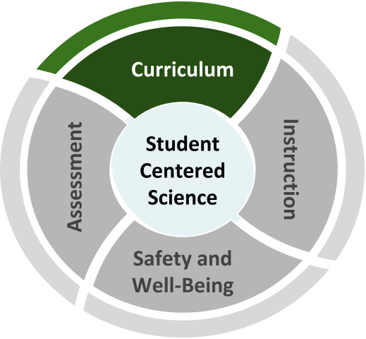
Science Curriculum
Back-to-School Considerations
How should schools decide what needs to be taught in science while adapting to different modes of learning?
Schools need to decide how to address science standards in a way that prioritizes equity and grade-level learning. Science practices, crosscutting concepts, and disciplinary core ideas build over time; sequences and materials need to be adapted accordingly.
Tensions We Are Navigating

- Teachers may be asked to provide remediation or re-teaching; however, students will start the school year with a diversity of skills, knowledge, and wonderings about the world that can be honored through “just-in-time” supplementation and adjustments (see vignette on next page).

  - Many elementary teachers are being directed to focus on math and ELA; however, science is a critical part of a well-rounded education for all students.
Science must not be crowded out of the curriculum.

  - Equity requires meeting the needs of all students, including those whose needs are often underserved, through multiple modes of learning; however, high-quality materials aligned to the pedagogical vision of the Framework for K—12 Science Education are not widely available or in use, especially in multiple formats.

  - Teachers need time to collaborate and plan, both within and between grade levels; however, time is stretched thin and teachers may be on different schedules, which may make finding common times difficult.

Recommended Reflection Questions
Use these questions with your PLC to examine current practice and engage in forward planning.
  - How will you ensure equitable access to on-grade learning? What practices or tools can you use to review curriculum and remove extraneous material that is not on grade-level, e.g. favorite activities or textbook chapters that are not standards-aligned?
  - Do existing resources prioritize student
sense-making using the three dimensions rather than discrete content? If materials unnecessarily focus on skill attainment in isolation (e.g. teaching metric system or scientific method), can these skills be developed in more meaningful ways?
  - How can existing materials be adapted for various learning scenarios in ways that do not disadvantage any students?

Science Curriculum
Where can we start?
Administrators
Support teachers to collaborate, plan, and adjust on a regular basis. Understand the unique needs of science teaching and learning, including time, space, and resources.
★ Stem Teaching Tool for Administrators
★ Highlights from 2018 National Survey of Science and Mathematics Education
★ Science Instructional Materials that Support At-Home Learning

Teachers
Keep science teaching and learning coherent, by considering bundling standards and storylining. Address requisite skills and knowledge in ways that are focused on
grade-level learning.
★ Next Generation Science Storylines
★ Bundling the NGSS
★ Supporting Students in Meaningful Engagement Through NGSS Storylines

Students, Families, and Communities Support student science learning at home by making connections to topics and activities that are meaningful to you.
★ Advice for Families (translations)
★ Advice for Students (translations)

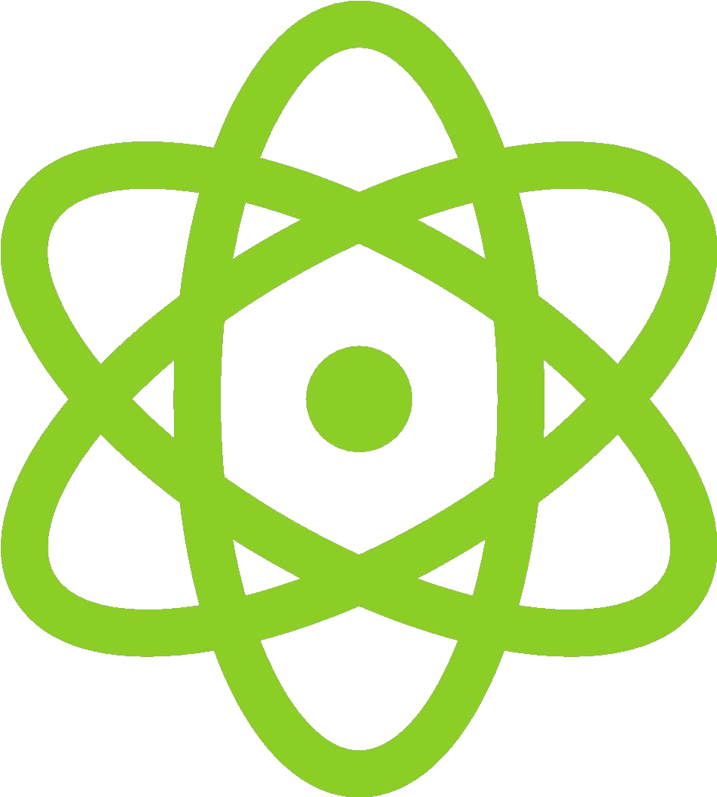
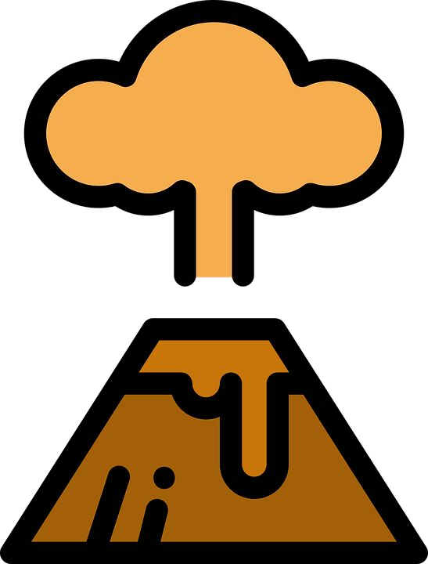
Back-to-School Considerations

Vignette: “Just-in-time” Supplementation
Use the Reflection Questions or Big Questions to guide a discussion with peers about this vignette.

Ms. Kim teaches 5th grade. Learning-from-home assignments in the spring focused on mathematics and ELA. Ms. Kim wants to focus on grade-level learning, and adjust her curriculum map without spending time on disconnected assessments at the beginning of the year.

To help adjust her plans, Ms. Kim reaches out to #NGSSchat to ask for ideas about how the practices, crosscutting concepts, and core ideas connect between 4th and 5th grade. Her 5th grade team also collaborates with the 4th grade team.

The 5th grade team initially focuses on a 5th grade ecosystems unit, integrating some pieces from a 4th grade unit on energy to scaffold toward using models to describe that that energy in animals’ food was once energy from the sun. Ms. Kim adjusts her pacing guide to spend additional time supporting her students with the practice of constructing explanations.
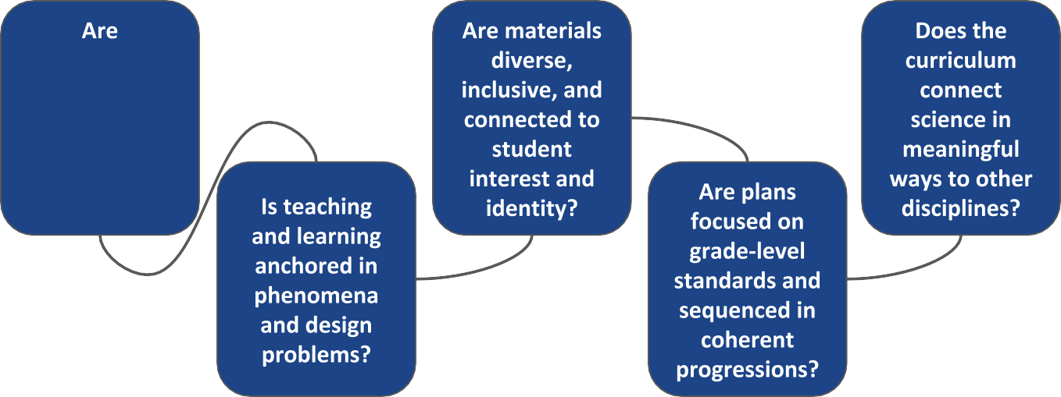
Big Questions for Curriculum

curriculum maps and curricular materials three- dimensional?

